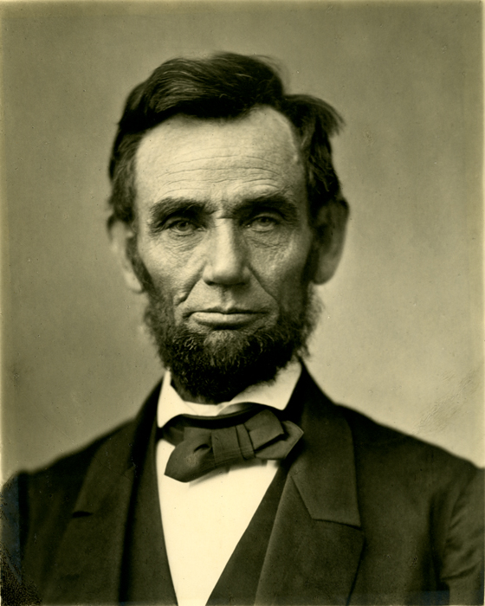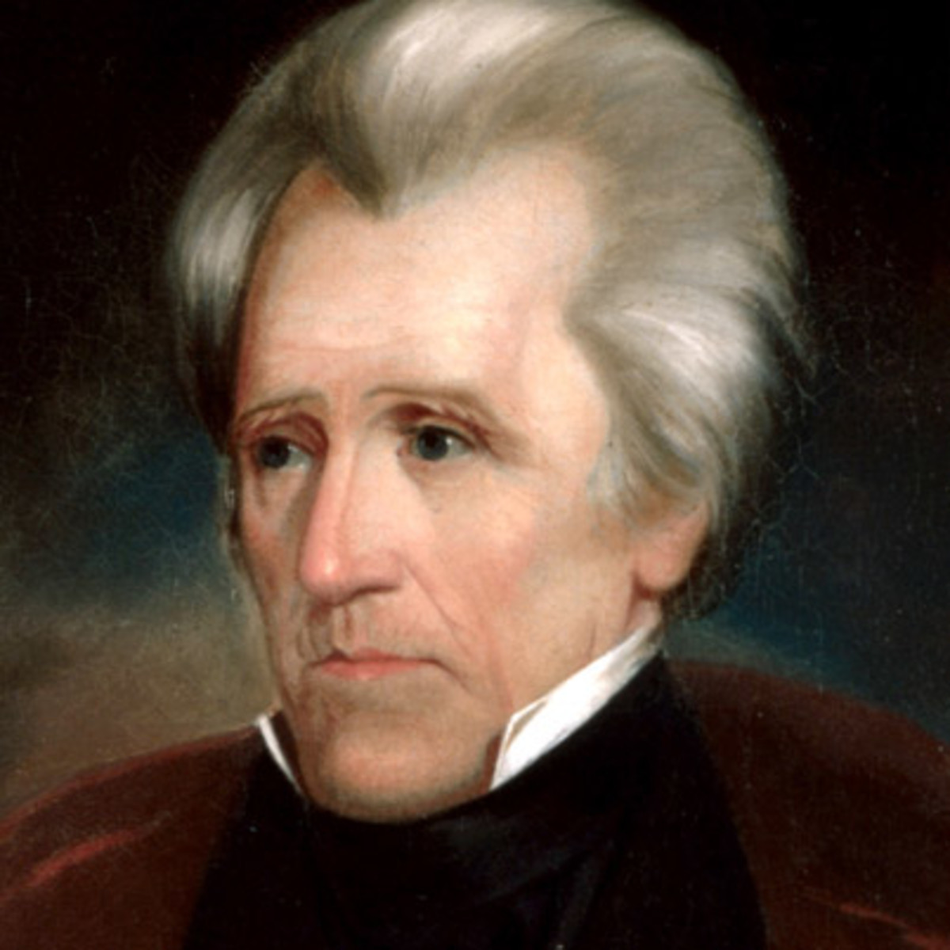

Print these images and cut them out. On the back of each, identify:

* The name of the US President
* How they link in with your studies of the American West (perhaps any legislation/act passed/deals with the Indians/encouragement of westward expansion/ key events that happened whilst they were President)

**DO NOT SIMPLY GOOGLE FACTS ABOUT THEM – YOU MUST ENSURE THAT IT IS RELEVANT TO WHAT YOU HAVE BEEN STUDYING IN CLASS**

1861-1865

1829-1837

Print these images and cut them out. On the back of each, identify:

* The name of the US President
* How they link in with your studies of the American West (perhaps any legislation/act passed/deals with the Indians/encouragement of westward expansion/ key events that happened whilst they were President)

**DO NOT SIMPLY GOOGLE FACTS ABOUT THEM – YOU MUST ENSURE THAT IT IS RELEVANT TO WHAT YOU HAVE BEEN STUDYING IN CLASS**

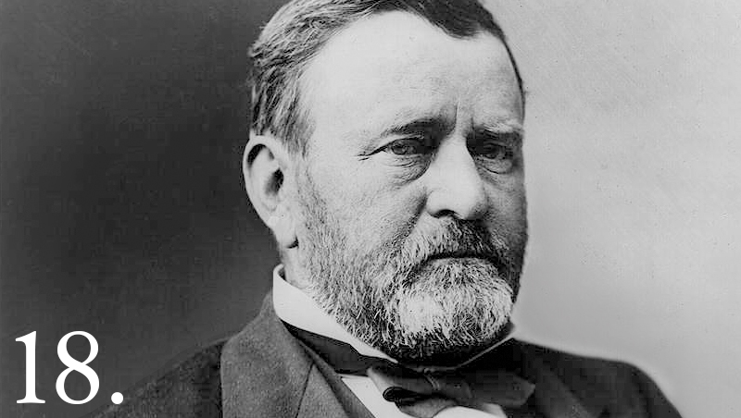

1869-1877

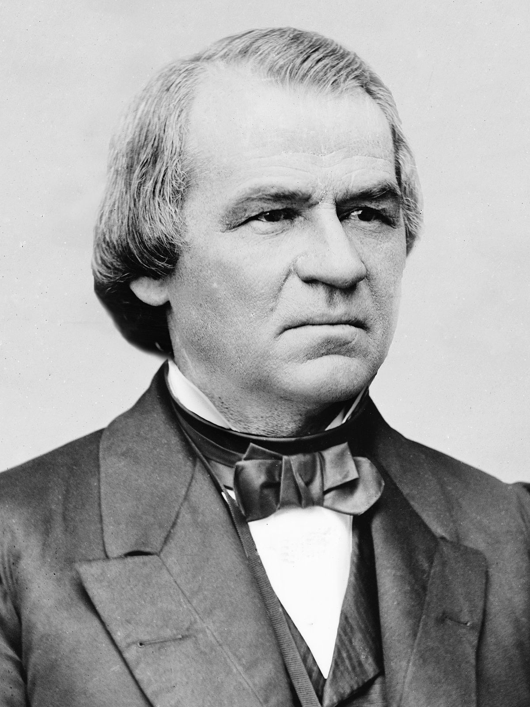

1865-1869