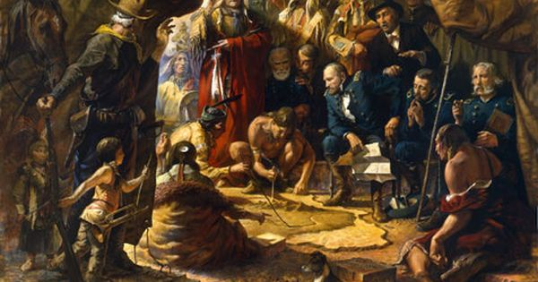

1868 - TOFL

What event is this?

What happened?

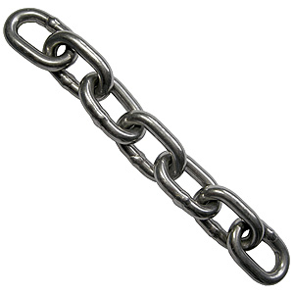

How did this event lead to the next?

1876 - BOLBH

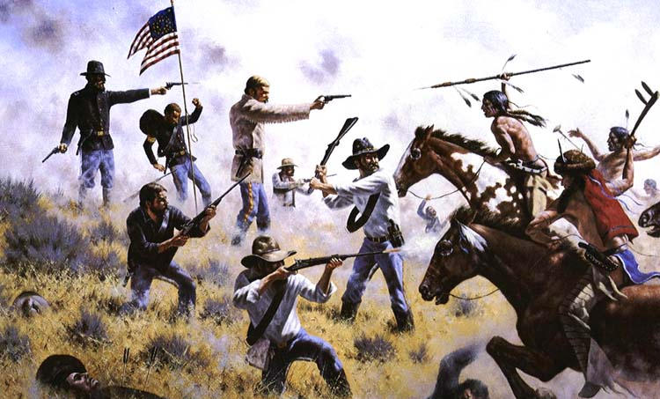

What event is this?

What event is this?



How did this event lead to the next?

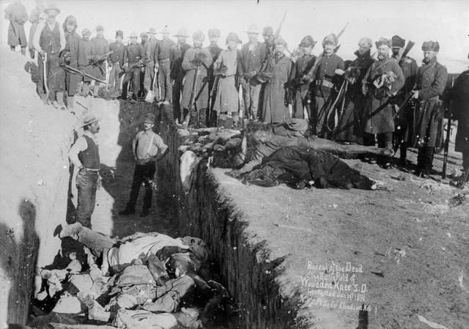

1890 - WKM

What event is this?

What event is this?