Below draw two diagrams: one showing the Anglo-Saxon hierarchy and another showing the Norman feudal system.
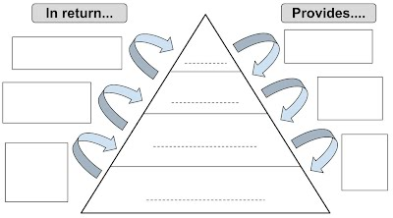
Anglo-Saxon Hierarchy

Norman Feudal System

Task Two

- Overall, what are the clear differences between these two systems?
_______________________________________________________________________________________________________________________________________________________________________________________________________________________________________________________________________________________________

- Would you say that William I’s changes were radically different from what England had previously been? Explain.
_________________________________________________________________________________________________________________________________________________________________________________________________________________________________________________________________________________________________________________________________________________________________________________

