Revision Session 4
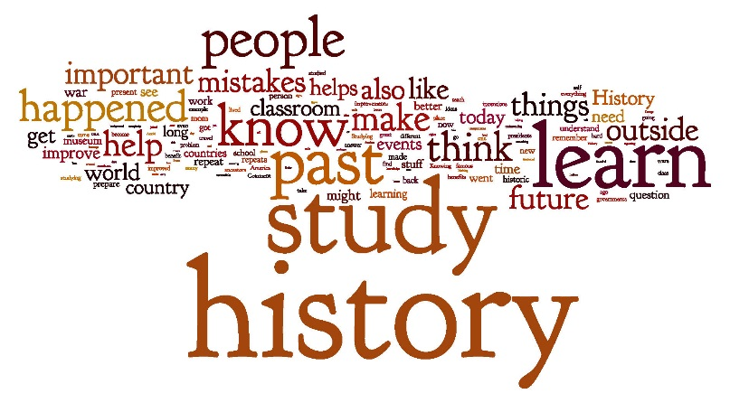
A Wordle is is basically when you create “word clouds” from text that you provide. The clouds give greater prominence to words that are more important. You can tweak your clouds with different fonts, layouts, and color schemes. The images you create with Wordle are yours to use however you like!

- For each of the areas below, create a wordle of key words, phrases, people involved etc. Use different colours, different fonts, different sizes etc. Make them as exciting as possible!

- Rebellions against Norman rule
- Normanisation of England
- The succession crisis (who should be king in 1066?)
- Anglo-Saxon society
- Anglo-Saxon monarchy

- Pin these up on your wall, and spend some time looking through them.

- Now go give them to a parent/guardian/sibling/friend and have them ask you about each area. See how much you can remember!

