However, William’s control of the church did very little to create a governing class of Normans in his new kingdom. His changes in to landholdings was able to achieve this.
How he did it

Why was it so important?

On the one hand, control of the church was a very important impact…
How he did it

Why was it so important?

Overall – was William’s control of the church the most important impact? Explain below! Be sure to compare each factor.

In addition, another important impact of William’s
Normanisation was…

Was William I’s increased control of the Church the most important impact of his ‘Normanisation’ of England?
What are these earldoms called?
Give three examples of these earldoms.
Below, identify three reasons why these earldoms were created by William.
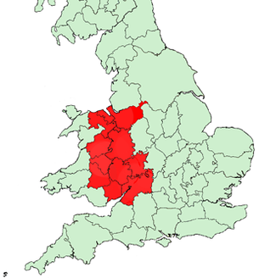

Reason 2: _______________________________

Explain what you mean by this with precise own knowledge

Reason 3: ______________________________________

Explain what you mean by this with precise own knowledge

Reason 1: ______________________________________

Explain what you mean by this with precise own knowledge

