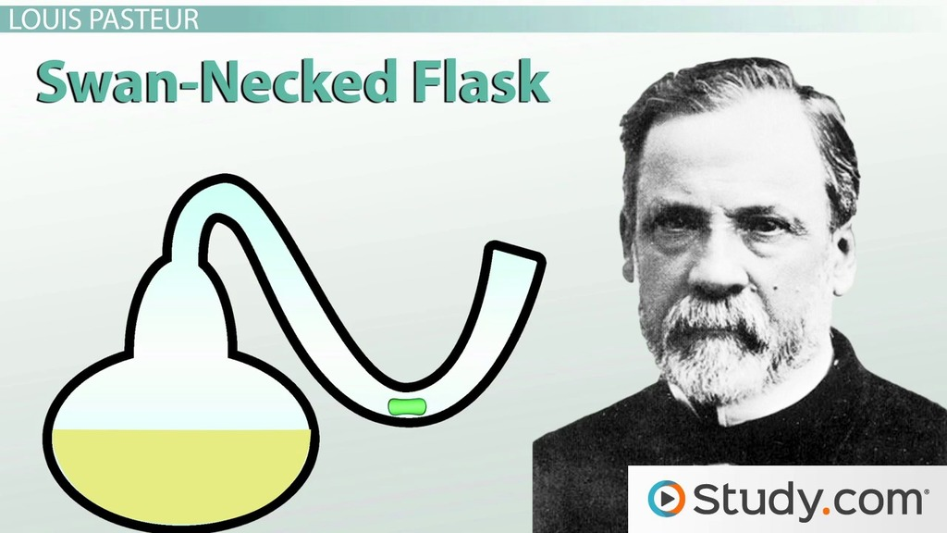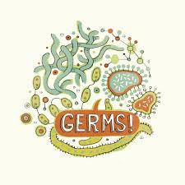

**In a paragraph or a sketch (or a mixture of both), explain how the ‘Swan Neck’ experiment worked**

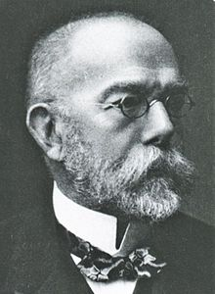

The work of Robert Koch

The four principles of Germ theory are…





1. _________________________
2. _________________________
3. _________________________
4. _________________________