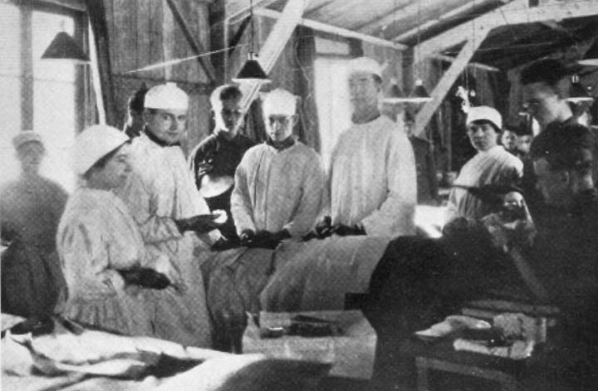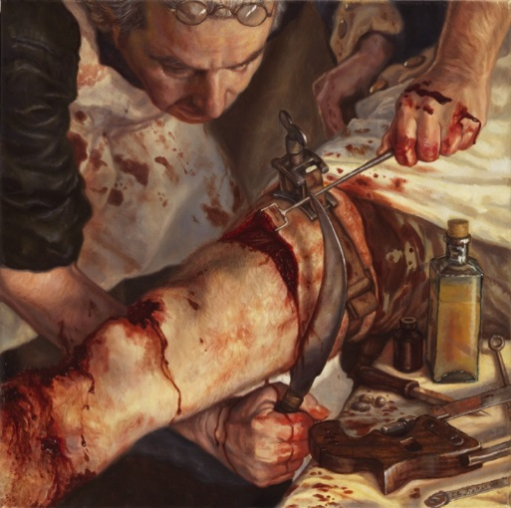



Photograph is from 1914

* Surgeons and nurse are wearing rubber gloves, to prevent infection.
* Aprons are clean and free of blood or germs.
* Patient is not moving, so anaesthetic has been used.
* The air will have been sterilized through the air vents.
* All equipment will have been sterilised by an autoclave.

Probably late 18th Century.

* Surgeon is not wearing gloves, nor is he wearing clean overalls. This will cause infection.
* Tournekey is being used to restrict blood flow.
* Curved blade is being used to cut flesh and muscle.
* Patient is being held down by another person, suggesting no anaesthetic.