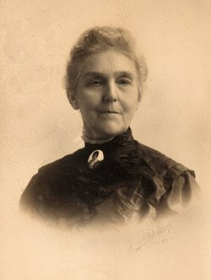
Altho I was but a girl of 11 years I distinctly remember many things connected with that far-off time when all of our western country was a wilderness... We were six months in crossing the plains in ox-wagons.
In our home, in Illinois, in the early fifties, there was much talk and excitement over the news of the great gold discoveries in California -- and equally there was much talk concerning the wonderful fertile valleys of Oregon Territory -- an act of Congress giving to actual settlers 640 acres of land.
An open country was now before us. The melting snows had made the streams high, the roads nearly impassable. The Platte river, swift and swollen, didn't seem to have any banks.
My mother kept the two youngest with her always in "Mother's wagon". Her health was not very good, and she had dreads and fears, but hoped she would live to get to Oregon. Fate willed it otherwise, and being frail and weary with the long journey, she fell a victim to the cholera, so prevalent that year on the plains, leaving her sorrowing family to grieve for her. When we reached Wyoming, there in the Black Hills, this side of Ft. Laramie, the passing of that dear, beloved mother was a crushing blow to all our hopes. We had to journey on, and leave her in a lonely grave -- a feather bed as a coffin, and the grave protected from the wolves by stones heaped upon it. The rolling hills were ablaze with beautiful wild roses -- it was the 20th of June, and we heaped and covered mother's grave with the roses so the cruel stones were hid
On and on we journeyed -- averaging 15 miles a day over cactus, sagebrush, hot sand. Everybody's shoes gave out and we bartered with Indians for moccasins, but that didn't help much about the prickly pears. One by one the oxen fell by the way. We came to Burnt River -- a most desolate country. Here our baby brother Willie fell sick. It was in the heat of August. The train was halted, that the darling child of 4 years could be better cared for, but he became unconscious and passed away. The soil here was thin and full of rocks. My poor father, broken-hearted, had the men cut a cavity out of the solid rock jutting out of Burnt River Mountain, and here the little form was sealed beside where the only living thing was --- a little juniper tree. My brother Harvey found it, twenty years later, and he peeled some of the bark off of the juniper tree and brought it back to my father. My father had carved Willie's name on the tree.

